RESEARCH ANALYSIS.
Student name
Institution affiliations
Date.

Introduction.
Research analysis refers to the activities involved in making sense and finding meanings of the data collected during qualitative and quantitative research. It encompasses the methods involved in the interpretation of the data collected by using logical reasoning and performing analytics to find patterns, relationships, and trends (Tesch, 2013). Data analysis is performed through the following steps. Firstly, the researcher needs to define the objectives of the research so that the analysis aims at satisfying those objectives. For instance, the objectives of this research were to: to establish the effect of workplace culture on employee retention, to establish how training influences employee retention, to assess how the availability of motivation influences employee retention, to analyze how job performance influences employee retention and, to assess how work engagement influences employee retention. The second step of data analysis involves posing the questions you would like your research to answer. For instance, the research questions for this research involved the following: what is the effect of workplace culture on employee retention? how does motivation influence employee retention? How does motivation affect employee retention? How does job performance influence employee retention? How does work engagement influence employee retention?
The third step of data analysis involves identifying the data collected from various sources. For instance, data can be collected from organizational reports, insurance reports, and health reports. That is this research involved the collection of data from the employees of the organization, organizational health and financial records, and insurance information from the related insurance company. After reviewing the data collected, data analysis involves data scrubbing. Data scrubbing taking of data collected from different sources in different formats to find clean and useful information. The clean data is then imported into data analysis tools that give the researcher the ability to locate patterns and answer questions that may arise. Lastly, the cleaned data is then used to make predictions conclude the research (Bailey, 2008). For instance, the analysis involved making conclusions about the strategies to ensure employee retention is maintained or improved within the organization.
Research analysis plays an important role in any organizational project. That is, it helps an organization to come up with better decisions. For quantitative research, data analysis is done through content analysis, narrative analysis, discourse analysis, and grounded theory. Content analysis is dependent on research questions to predict results and it analyses documented information. Narrative analysis analyses data gathered from interviews, surveys, questionnaires, and observation. Discourse analysis observes data from social contexts and interaction focusing on daily lifestyle and grounded theory involves using theories to explain similar occurrences of events (Sgier, 2012)
This chapter focuses on the aims at explaining the methods used for analysis to comprehend the factors that influence employee retention in an organization. It explains the use of descriptive analysis to do statistical tests, the use of Cronbach's Alpha test to test hypotheses. The research also does Pearson's correlation test and multiple regression analysis. The general process involved screening and checking the collected data for accuracy, completeness, and understandability. The data was then summarized, through frequency distribution tables.
Descriptive analysis.
The descriptive analysis involves the process of using different basic components to describe simple information in the study. They help in the provision of summaries about the data and thy form the basic features of quantitative analysis of data. The descriptive analysis allows the researcher to simplify enormous amounts of data functionally. Descriptive analysis is cheap and easier to and may be done over a large area population. However, descriptive data cannot be used to generalize information. Descriptive analysis was used to analyze demographic information such as gender participation, age of respondents, and work experience. It was also used to present the research finding concerning the questions answered in the questionnaire.
Demographic analysis.
Gender
The written questionnaires were sent out to employees of the organization and led to a total of N=162. The total number of women answering the survey is 55 (approx. 44.0%), with the total of men being 102 (approx. 66,0%) answered.
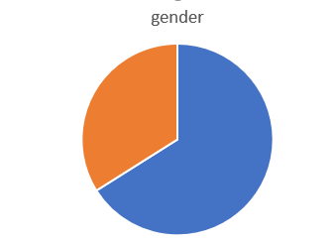
Age of respondents.
Most of the respondents (47.0%) are below 31 years, followed by 39.0% being between 31 and 40 years old. The third biggest group (7.0%), is between 41 and 50 years old, while also 7.0% stated being above 51 years.
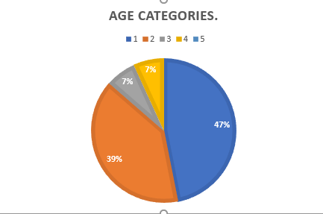
Working experience.
The respondents have had a fresh start at their current employer, being employed for under two year (23.0 %), or for rather short periods of 3 years to 5 years (20.0%) Longer periods were 6 years and above was 57.0%

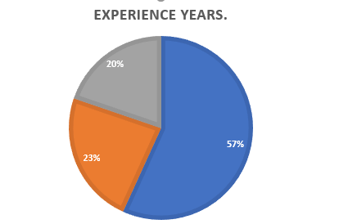
Educational background.
The organizational employees were mostly graduating from bachelors with 66.0% which makes 107 employees and 55 employees with Masters degree forming 34.0%

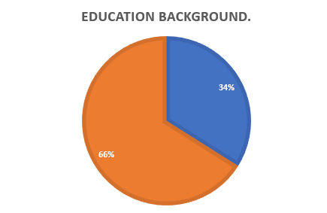

Result presentation.
Q1 – I describe my workplace environment as a culture that is trusting, honest, and fair to all employees.
A total of 52 (32.0%) respondents of the population strongly agreed with the above statement, 35(22.0%) agreed, 40(25.0%) neither agreed nor disagreed, 22(13.0%) disagreed, and 13(8.0%) strongly disagreed.
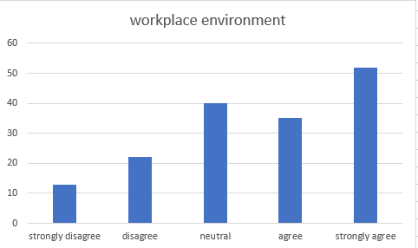

Q2 – I think culture affect behaviors and performance in my organization
A total of 81 (39.0%) respondents of the population strongly agreed with the above statement, 34(26.0%) agreed, 32(24.0%) neither agreed nor disagreed, 10(7.0%) disagreed, and 5(4.0%) strongly disagreed.
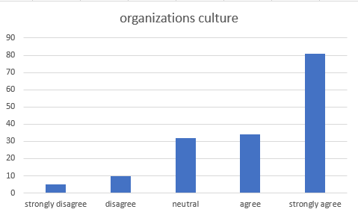
Q3 – Employee involvement is positively related to employee performance and job satisfaction
A total of 74 (46.0%) respondents of the population strongly agreed with the above statement, 51(31.0%) agreed, 30(19.0%) neither agreed nor disagreed, 5(3.0%) disagreed, and 2(1.0%) strongly disagreed.
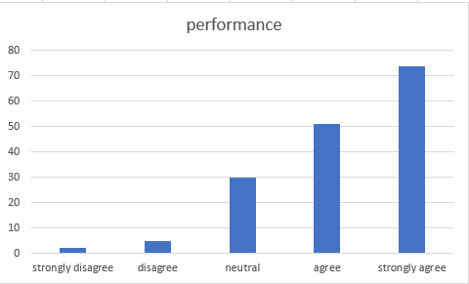
Q4 – My organization measure employee engagement
A total of 53 (33.0%) respondents of the population strongly agreed with the above statement, 33(21.0%) agreed, 36(22.0%) neither agreed nor disagreed, 27(17.0%) disagreed, and 13(7.0%) strongly disagreed.
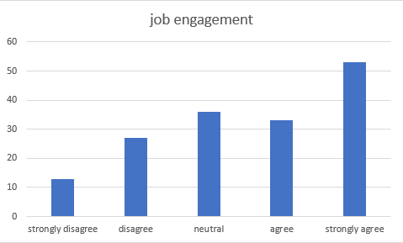
Q5 – Training improves the overall organization's profitability, effectiveness, productivity, and revenue, and other outcomes that are directly related to the training in improving the quality of service.
A total of 64 (39.0%) respondents of the population strongly agreed with the above statement, 48(28.0%) agreed, 35(20.0%) neither agreed nor disagreed, 4(2.0%) disagreed, and 11(7.0%) strongly disagreed.
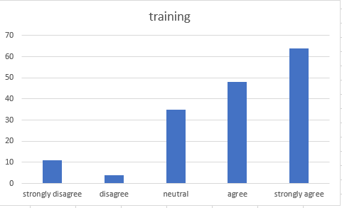
Q6 – Training improves the overall organization's profitability, effectiveness, productivity, and revenue, and other outcomes that are directly related to the training in improving the quality of service.
A total of 67 (42.0%) respondents of the population strongly agreed with the above statement, 41(25.0%) agreed, 32(20.0%) neither agreed nor disagreed,15(9.0%) disagreed, and 7(4.0%) strongly disagreed.
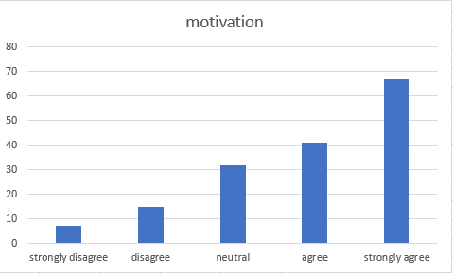
Q7 – At my job, I feel strong and vigorous.
A total of 34 (21.0%) respondents of the population strongly agreed with the above statement, 56(34.0%) agreed, 53(32.0%) neither agreed nor disagreed,14(8.0%) disagreed, and 8(5.0%) strongly disagreed.
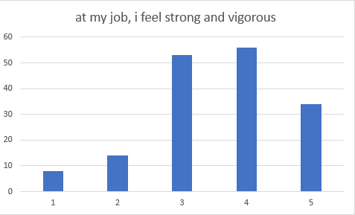
Q8 – At my work, I feel bursting with energy
A total of 36 (22.0%) respondents of the population strongly agreed with the above statement, 47(29.0%) agreed, 56(35.0%) neither agreed nor disagreed,14(9.0%) disagreed, and 9(5.0%) strongly disagreed.
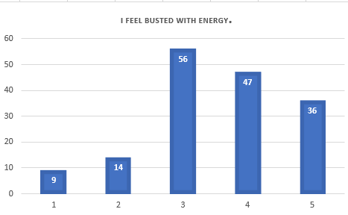
Q9 – I am enthusiastic about my job.
A total of 49 (30.0%) respondents of the population strongly agreed with the above statement, 45(28.0%) agreed, 40(25.0%) neither agreed nor disagreed,18(11.0%) disagreed, and 10(6.0%) strongly disagreed.
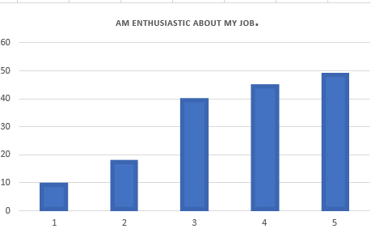
Q10 – my job inspires me
A total of 36 (22.0%) respondents of the population strongly agreed with the above statement, 47(29.0%) agreed, 56(35.0%) neither agreed nor disagreed,14(9.0%) disagreed, and 9(5.0%) strongly disagreed.
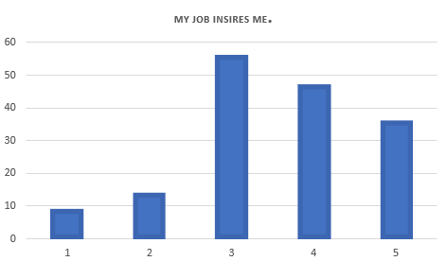
Q11 – when I wake up n the morning, I feel like going to work.
A total of 49 (28.0%) respondents of the population strongly agreed with the above statement, 34(20.0%) agreed, 36(21.0%) neither agreed nor disagreed,36(21.0%) disagreed, and 17(10.0%) strongly disagreed.
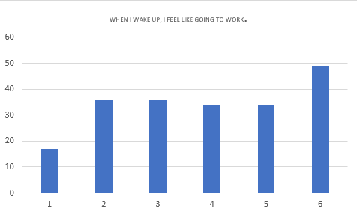
Q12 – I feel happy when I am working intensely
A total of 44 (27.0%) respondents of the population strongly agreed with the above statement, 52(32.0%) agreed, 42(26.0%) neither agreed nor disagreed,12(8.0%) disagreed, and 12(8.0%) strongly disagreed.
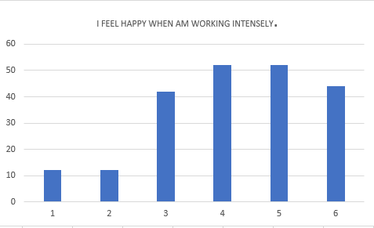
Q13 – Am proud of the work I do.
A total of 86 (53.0%) respondents of the population strongly agreed with the above statement, 42(26.0%) agreed, 17(10.0%) neither agreed nor disagreed,11(7.0%) disagreed, and 6(4.0%) strongly disagreed.
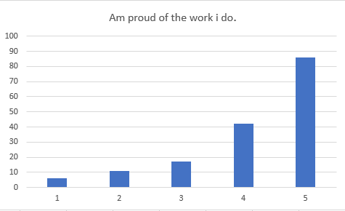
Q14 – I am immersed in my work.
A total of 57 (35.0%) respondents of the population strongly agreed with the above statement, 45(27.0%) agreed, 37(23.0%) neither agreed nor disagreed,12(8.0%) disagreed, and 11(7.0%) strongly disagreed.
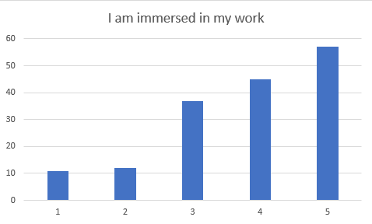
Q15– I get carried away when am working.
A total of 57 (35.0%) respondents of the population strongly agreed with the above statement, 44(27.0%) agreed, 39(24.0%) neither agreed nor disagreed,12(8.0%) disagreed, and 10(6.0%) strongly disagreed.
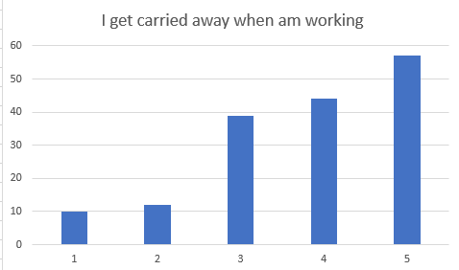
Q16– Am planning on working for another company within three years.
A total of 59 (39.0%) respondents of the population strongly agreed with the above statement, 33(20.0%) agreed, 28(17.0%) neither agreed nor disagreed,16(10.0%) disagreed, and 26(16.0%) strongly disagreed.
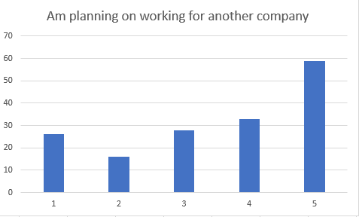
Q17– Within this company, my work gives me satisfaction
A total of 58 (38.0%) respondents of the population strongly agreed with the above statement, 35(21.0%) agreed, 30(22.0%) neither agreed nor disagreed,14(9.0%) disagreed, and 25(6.0%) strongly disagreed.
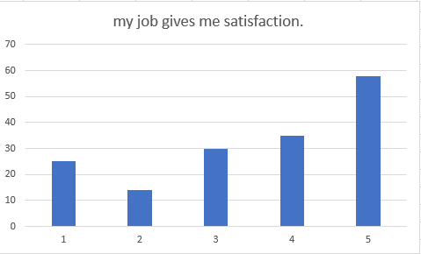
Q18– It doesn’t matter if am working for this company or another, as long as I have work.
A total of 50 (31.0%) respondents of the population strongly agreed with the above statement, 21(13.0%) agreed, 37(23.0%) neither agreed nor disagreed,24(18.0%) disagreed, and 30(18.0%) strongly disagreed.
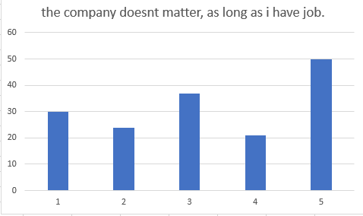
Q19– If I could start over again, I would choose to work for another company.
A total of 59 (39.0%) respondents of the population strongly agreed with the above statement, 33(20.0%) agreed, 28(17.0%) neither agreed nor disagreed,16(10.0%) disagreed, and 26(16.0%) strongly disagreed.
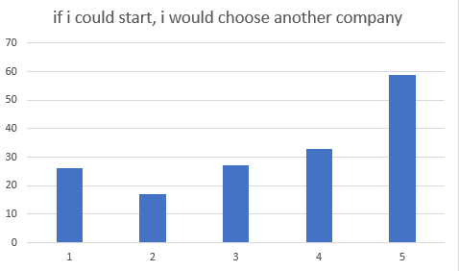
Q20– The work am doing is very important to me.
A total of 57 (35.0%) respondents of the population strongly agreed with the above statement, 44(27.0%) agreed, 39(24.0%) neither agreed nor disagreed,12(8.0%) disagreed, and 10(6.0%) strongly disagreed.
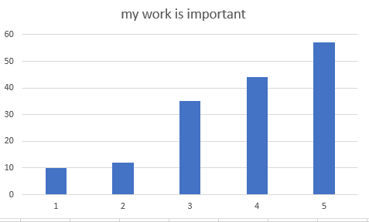
Q21– I perform well in the overall job by carrying out tasks as expected.
A total of 58 (38.0%) respondents of the population strongly agreed with the above statement, 35(21.0%) agreed, 30(22.0%) neither agreed nor disagreed, 25(6.0%) disagreed, and 14(9.0%) strongly disagreed.
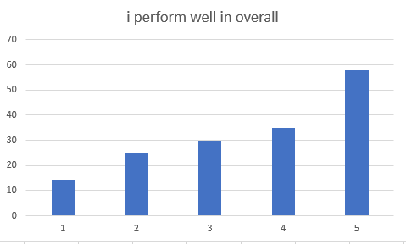
Q22– My organization promote an effective reward system
A total of 34 (21.0%) respondents of the population strongly agreed with the above statement, 32(20.0%) agreed, 41(26.0%) neither agreed nor disagreed,27(17.0%) disagreed, and 26(16.0%) strongly disagreed.
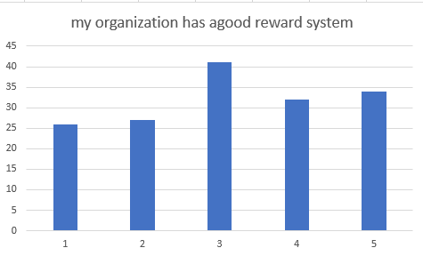
Q23– Employees have the perception to acquire new knowledge and skills which they apply on the job and also share with another employee
A total of 57 (35.0%) respondents of the population strongly agreed with the above statement, 44(27.0%) agreed, 39(24.0%) neither agreed nor disagreed,12(8.0%) disagreed, and 10(6.0%) strongly disagreed.
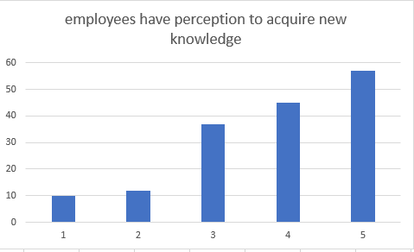
Q24– Training improves the overall organization's profitability, effectiveness, productivity, and revenue, and other outcomes that are directly related to the training in improving the quality of service.
A total of 50 (31.0%) respondents of the population strongly agreed with the above statement, 61(38.0%) agreed, 36(22.0%) neither agreed nor disagreed,4(2.0%) disagreed, and 11(7.0%) strongly disagreed.
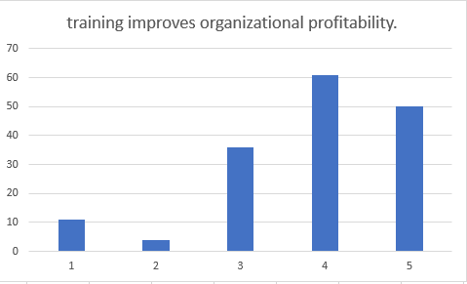
Q25– Conflict that such instructing would increase the value of the association by helping its workers develop and create and consequently improve the general generation.
A total of 57 (35.0%) respondents of the population strongly agreed with the above statement, 44(27.0%) agreed, 39(24.0%) neither agreed nor disagreed,12(8.0%) disagreed, and 10(6.0%) strongly disagreed.
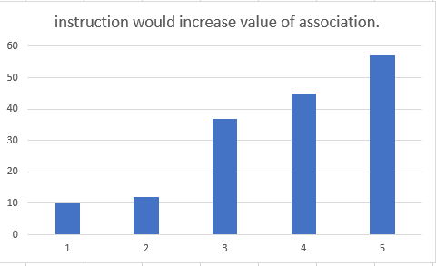
Q26– My organization support further development of employee skills related to required duties of the job
A total of 54 (33.0%) respondents of the population strongly agreed with the above statement, 41(25.0%) agreed, 36(22.0%) neither agreed nor disagreed,20(13.0%) disagreed, and 11(7.0%) strongly disagreed.
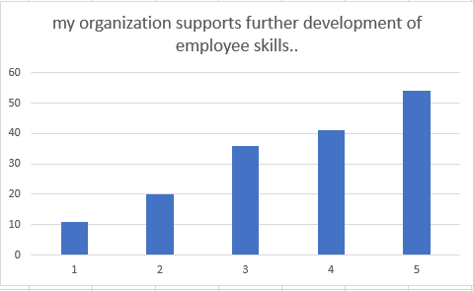
Q27– Drilling and tutoring can give an adaptable responsive advancement approach that can use to bolster an expanding number of people inside the association than conventional types of preparing consequently vocation development.
A total of 43 (27.0%) respondents of the population strongly agreed with the above statement, 46(28.0%) agreed, 50(31.0%) neither agreed nor disagreed,12(7.0%) disagreed, and 11(7.0%) strongly disagreed.
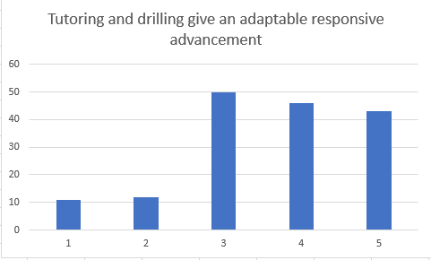
Q28– I willingly attend functions not required by the organization but helps in its overall image.
A total of 44 (27.0%) respondents of the population strongly agreed with the above statement, 52(32.0%) agreed, 42(26.0%) neither agreed nor disagreed,12(8.0%) disagreed, and 12(8.0%) strongly disagreed.
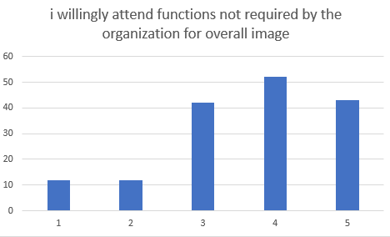
Q29– I take initiative to orient new employees to the department even though not part of my job description.
A total of 52 (32.0%) respondents of the population strongly agreed with the above statement, 42(26.0%) agreed, 42(26.0%) neither agreed nor disagreed,13(8.0%) disagreed, and 13(8.0%) strongly disagreed.
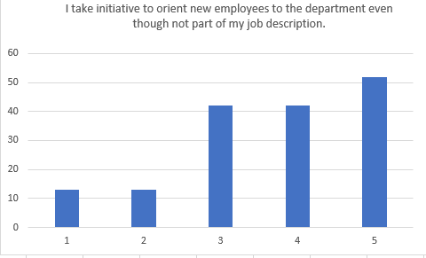
Q30– I help other employees with their work when they have been absent.
A total of 42 (26.0%) respondents of the population strongly agreed with the above statement, 50(31.0%) agreed, 46(28.0%) neither agreed nor disagreed,14(9.0%) disagreed, and 10(6.0%) strongly disagreed.
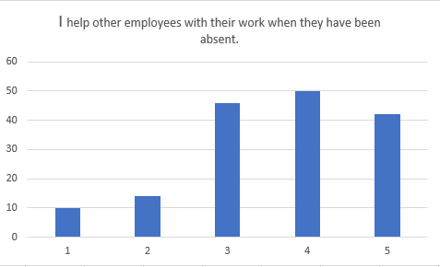
Q31– I am aware of my organization values, beliefs, and behaviors
A total of 81 (39.0%) respondents of the population strongly agreed with the above statement, 34(26.0%) agreed, 32(24.0%) neither agreed nor disagreed, 10(7.0%) disagreed, and 5(4.0%) strongly disagreed.
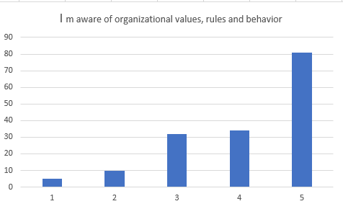

Cronbach’s Alpha test.
A hypothesis is a projected explanation made on the assumption that the explanation is true and that it is the starting point for further investigation (Santos, 1999). This research utilizes the Cronbach’s Alpha test to test for the hypothesis of the research (Tavakol et al, 2011). This method involves measuring how closely related the items in the scale are. Cronbach’s Alpha test can be written as a function in the formula below:
$Cronbach^{'}salpha=\frac{Nc}{v+\left(N-\right)c}$
In this research, there are five questionnaire questions to measure the influences of those factors on employee retention at an organization. Each question involved a five-point Likert item from strongly agree to strongly disagree. To understand the reliability measure of those variables, Cronbach's Alpha was run on a sample of 10 employees of that organization.
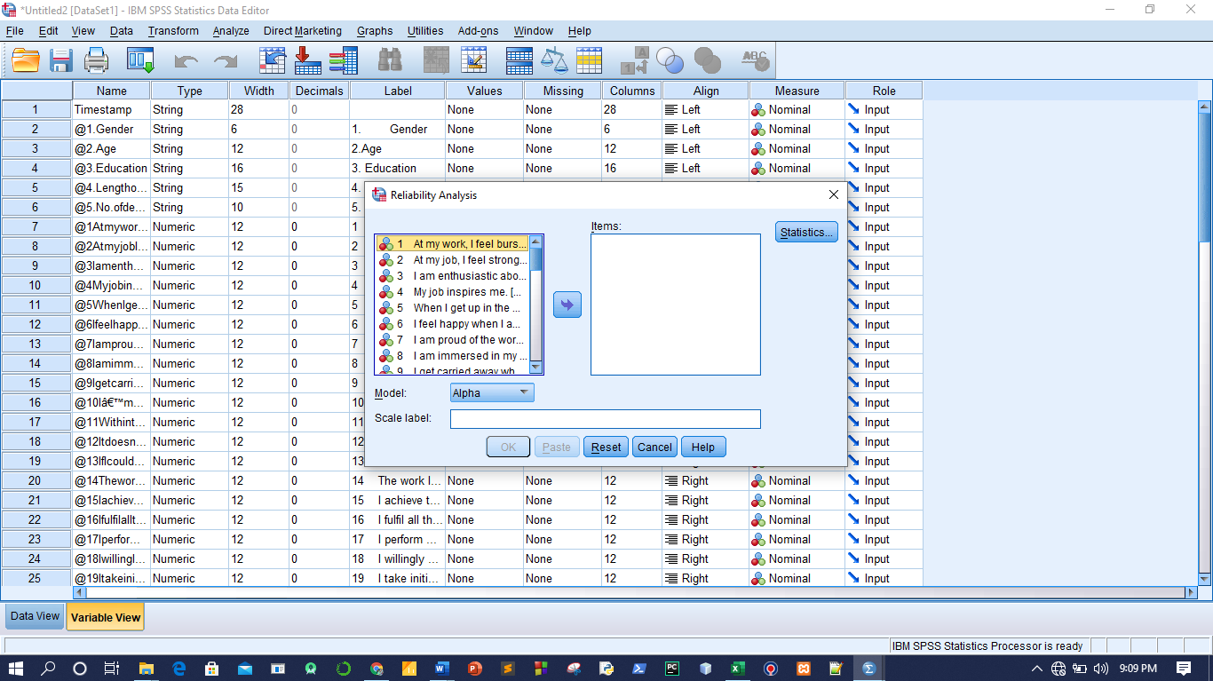
The output:
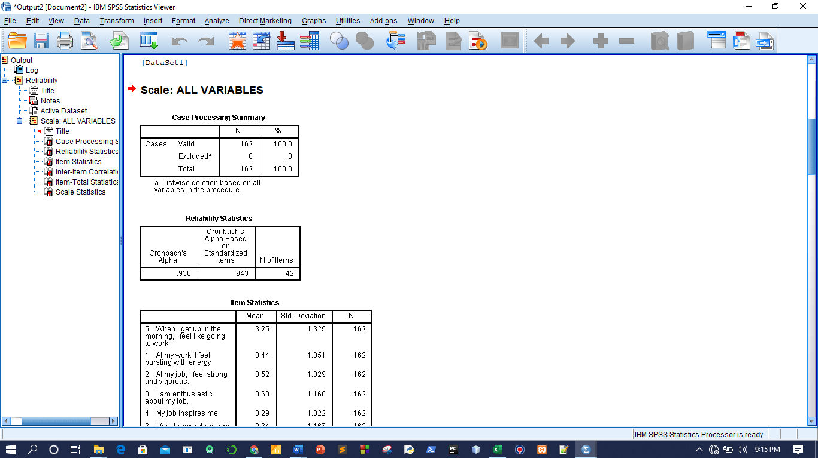
From the SPSS data, the Cronbach's Alpha is 0.938, which indicates a very high level of internal consistency concerning employee retention in that particular organization. The table below shows the Item-Total statistics if Item is Deleted.
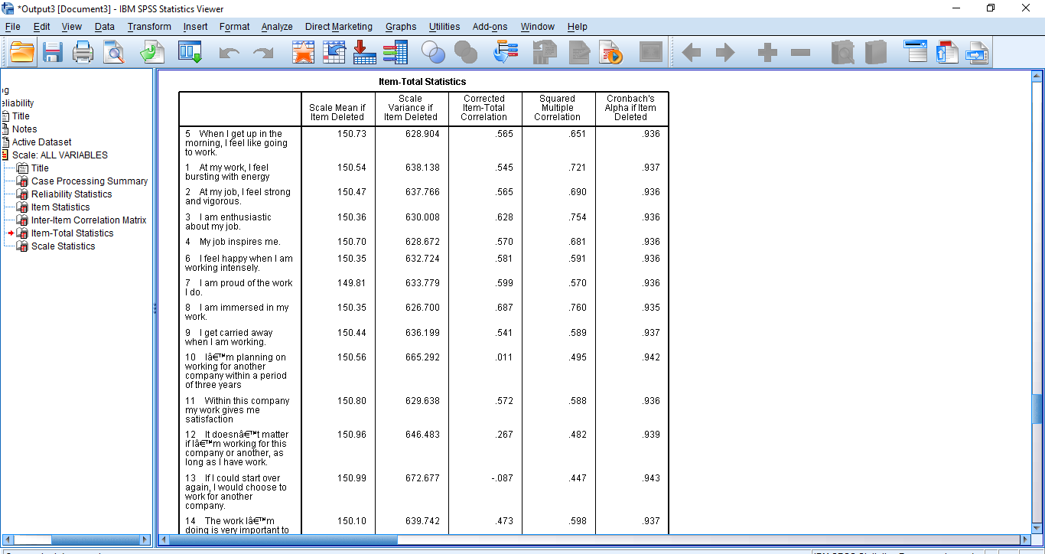
Pearson’s Correlation.
Pearson’s correlation is a technique used to investigate the associations between two variables that are quantitative and continuous (Hauke et al, 2011)). In this research, Pearson's correlation was used to determine the relationship between age, experience years, and level of education and how they influence employee retention within the organization. Therefore, the co-efficient represents the strength of association between the variables (Segwick, 2012)
In this research, using SPSS to calculate the person's correlation involves specifying the height and the weight than running the Bivariate Pearson's correlation. The results are as shown in the table below.
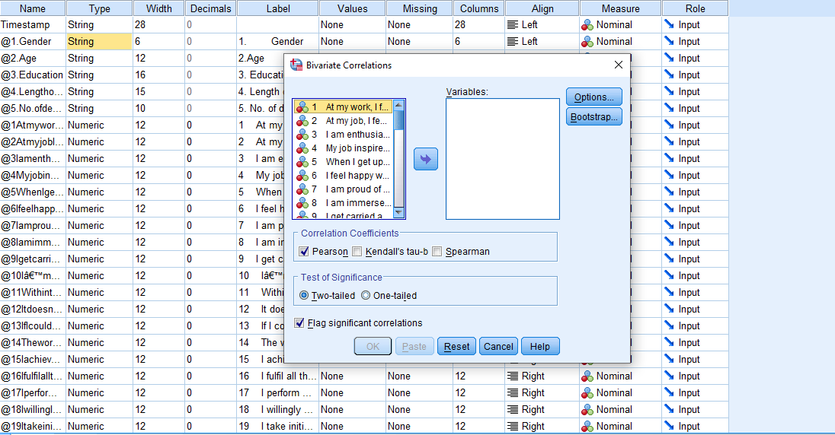
The figure below shows the five variables that have been used to test for Pearson’s correlation with each other.
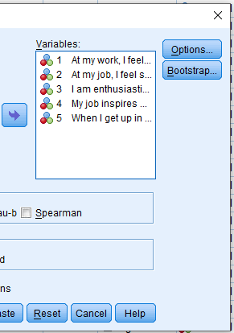
The output:

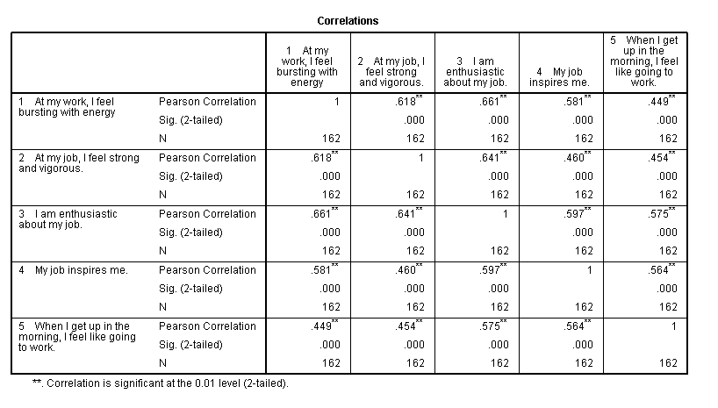
For instance, let’s utilize cases 3 and 4 to explain. The correlation of the height with itself is r=1 and the number of non-missing observations for the height is 162. The correlation of the height with itself is r=1 and the number of non-missing observations for the weight is 661 for case 3 and 581 for case 4. Therefore, since the direction of the relationship is positive, it shows that these variables tend to increase at the same together. In addition, all the weights and heights in this table are positive showing that these variables tend to increase together. That is, if an employee is inspired by his work, then when he wakes, he will feel like going to work and he will be enthusiastic about the job.
Multiple Regression Analysis.
Regression analysis refers to a method of sorting out variables mathematically (Chartteje et al, 2015). For instance, if the organization is trying to predict the number of employees that are likely to leave the organization, then we need to understand the five major factors that influence employee retention, that is, job performance, training, culture, work engagement, and motivation. In regression analysis, these factors may be divided into dependent and independent variables. Dependent variables represent the factors you are trying to study while independent variables represent the factors that have an impact on your dependent variable (Bates et al, 1988). Regression analysis helps the researcher to comprehend the factors that influence employee retention most, the factor that is to be assumed, and how these factors influence each other.
In this research, SPSS was used to do multiple regression analyses which is an extension of the simple regression analysis. Multiple regression is used to evaluate the overall performance of the model and the relations between two or more variables.
Dependent variable: Within this company, my job gives me satisfaction.
Independent variables:
I am immersed in my work.
I get carried away when am working.
If I could start all over again, I would choose to work for another company.
I feel happy when am working.
I am of the work I do.
At my job, I feel strong and vigorous.
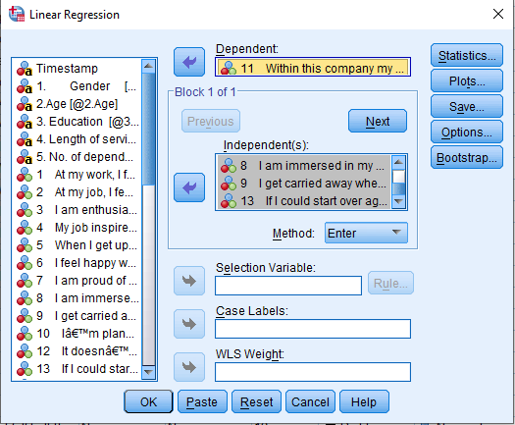
The results were analyzed and represented the following model summary. This summary represents the predictors of the research, that is, the factors that influence retention. The value of R is 0.785 which means that the factors are highly related to each other and the standard estimate of error is 0.728 shows that the error estimated is highly predicted during the analysis.
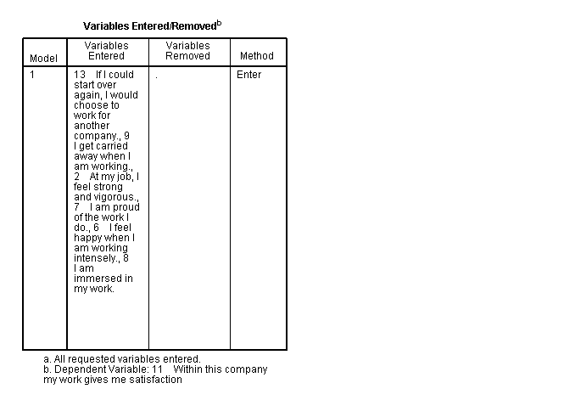
Model summary and Anova.

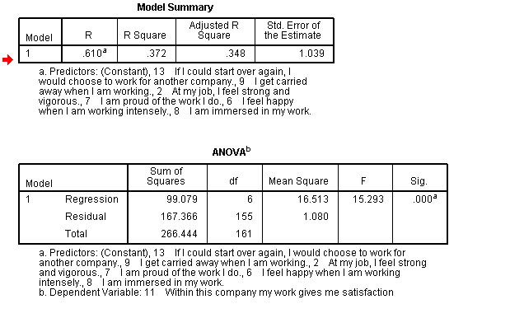
Coefficients.
Regression coefficients tells the researcher whether there is a positive and negative correlation between each independent variable and the dependent variable. Variables that have a positive coefficient value shows that when the mean of an independent value increases, the mean of the dependent variable will increase too. Generally, coefficient determines shift strength in relation to the model constant.
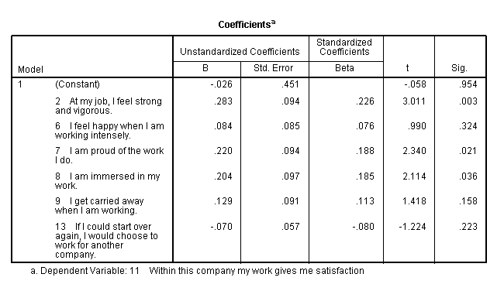
Conclusion.
To conclude the analysis of the collected results, the researchers assumed that training, motivation, job engagement, culture, and performance can influence employee retention of an organization. Most employees agreed or strongly agreed that these factors were considered in their organization. Moreover, the analysis also showed that employees that we're satisfied with their works were higher than those employees that planned to leave their jobs in the following three years. In general, understanding the SPSS software helped in the determination of Pearson's coefficients, Cronbach's alpha test to do the hypothesis, and the regression analysis to determine how dependent and independent variables influence each other.

References.
Aruna, M., & Anitha, J. (2015). Employee retention enablers: Generation Y employees. SCMS Journal of Indian Management, 12(3), 94.
Bailey, J. (2008). First steps in qualitative data analysis: transcribing. Family practice, 25(2), 127-131.
Bates, D. M., & Watts, D. G. (1988). Nonlinear regression analysis and its applications (Vol. 2). New York: Wiley.
Chatterjee, S., & Hadi, A. S. (2015). Regression analysis by example. John Wiley & Sons.
Hauke, J., & Kossowski, T. (2011). Comparison of values of Pearson's and Spearman's correlation coefficients on the same sets of data. Quaestiones geographical, 30(2), 87-93.
Santos, J. R. A. (1999). Cronbach’s alpha: A tool for assessing the reliability of scales. Journal of extension, 37(2), 1-5.
Sedgwick, P. (2012). Pearson’s correlation coefficient. Bmj, 345, e4483.
Sgier, L. (2012). Qualitative data analysis. An Initiat. Gebert Ruf Stift, 19, 19-21.
Tavakol, M., & Dennick, R. (2011). Making sense of Cronbach's alpha. International journal of medical education, 2, 53.
Tesch, R. (2013). Qualitative research: Analysis types and software. Routledge.

